TEST RESULTS

AND EVALUATION

REPORT

Ship Recommendation Report

Elena Stefanova

Revision Sheet

 | UNIT TEST |  | SVT TEST |  | INTEG. TEST |  | Month 5
Month 1 |  |  |  |  |  |  | # Cases |  |  | 1000 | 600 | 150
# Cases | 1000 |  | 600 |  | 150 |  | # Tried |  |  | 1000 | 500 | 60
# Tried | 450 |  | 25 |  | 0 |  | # Pass |  |  | 980 | 400 | 40
# Pass | 225 |  | 1 |  | 0 |  | # Failed |  |  | 20 | 100 | 20
# Failed | 225 |  | 24 |  | 0 |  | # Not Run |  |  | 0 | 100 | 90
# Not Run | 550 |  | 575 |  | 150 |  | % Complete |  |  | 0.980 | 0.667 | 0.267
% Complete | 0.225 |  | 0.002 |  | 0.000
 |  |  |  |  |  |  | Month 6
Month 2 |  |  |  |  |  |  | # Cases |  |  | 1000 | 600 | 150
# Cases | 1000 |  | 600 |  | 150 |  | # Tried |  |  | 1000 | 590 | 130
# Tried | 650 |  | 40 |  | 0 |  | # Pass |  |  | 990 | 550 | 100
# Pass | 325 |  | 5 |  | 0 |  | # Failed |  |  | 10 | 40 | 30
# Failed | 325 |  | 35 |  | 0 |  | # Not Run |  |  | 0 | 10 | 20
# Not Run | 350 |  | 560 |  | 150 |  | % Complete |  |  | 0.990 | 0.917 | 0.667
% Complete | 0.325 |  | 0.008 |  | 0.000
 |  |  |  |  |  |  | Month 7
Month 3 |  |  |  |  |  |  | # Cases |  |  | 1000 | 600 | 150
# Cases | 1000 |  | 600 |  | 150 |  | # Tried |  |  | 1000 | 600 | 150
# Tried | 850 |  | 100 |  | 1 |  | # Pass |  |  | 990 | 590 | 140
# Pass | 750 |  | 15 |  | 0 |  | # Failed |  |  | 10 | 10 | 10
# Failed | 100 |  | 85 |  | 1 |  | # Not Run |  |  | 0 | 0 | 0
# Not Run | 150 |  | 500 |  | 149 |  | % Complete |  |  | 0.990 | 0.983 | 0.933
% Complete | 0.750 |  | 0.025 |  | 0.000
 |  |  |  |  |  |  | Month 8
Month 4 |  |  |  |  |  |  | # Cases |  |  | 1000 | 600 | 150
# Cases | 1000 |  | 600 |  | 150 |  | # Tried |  |  | 1000 | 600 | 150
# Tried | 950 |  | 250 |  | 15 |  | # Pass |  |  | 995 | 595 | 145
# Pass | 930 |  | 125 |  | 5 |  | # Failed |  |  | 5 | 5 | 5
# Failed | 20 |  | 125 |  | 10 |  | # Not Run |  |  | 0 | 0 | 0
# Not Run | 50 |  | 350 |  | 135 |  | % Complete |  |  | 0.995 | 0.992 | 0.967
% | 0.930 |  | 0.208 |  | 0.033
DEFECT STATUS BY MONTH
Month |  | Open |  | Closed |  | %
1 |  | 50 |  | 200 |  | 25
2 |  | 125 |  | 400 |  | 31.25
3 |  | 75 |  | 525 |  | 14.2857143
4 |  | 75 |  | 525 |  | 14.2857143
5 |  | 100 |  | 675 |  | 14.8148148
6 |  | 600 |  | 600 |  | 100
7 |  | 100 |  | 1200 |  | 8.33333333
8 |  | 75 |  | 1300 |  | 5.76923077

TEST RESULTS AND EVALUATION REPORT

TABLE OF CONTENTS

Page #

1.0 GENERAL INFORMATION
1.1 Purpose
1.2 Scope
1.3 System Overview
1.4 Project References 1-1
2.0 TEST ANALYSIS
2.1 Security Considerations 2-2
2.x [Test Identifier] 2-3
2.x.1 Expected Outcome 2-4
2.x.2 Functional Capability 2-4
2.x.3 Performance 2-8
2.x.4 Deviations from Test Plan 2-8
2.x.5 Risk assessment 2-10
3.0 SUMMARY AND CONCLUSIONS
3.1 Demonstrated Capability
3.2 System Deficiencies
3.3 Recommended Improvements
3.4 System Acceptance

1.0 GENERAL INFORMATION

GENERAL INFORMATION

1.1 Purpose

- Analyze the data provided in the attached file "Test Results.xlsx"
- Support shipping the product based upon the test data provided
- Risk assessment
- Action plan

1.2 Scope

- UNIT TEST
- SVT TEST
- INTEG. TEST

1.3 System Overview

1.4 Project References

- Test Results.xls

2.0 TEST ANALYSIS

TEST ANALYSIS

The first 4 months there a lot of don not run cases and a lot failed cases.

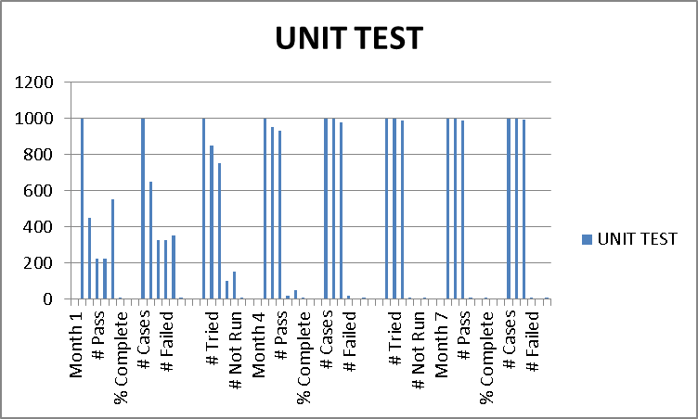

The first 4 months are again critical for SVT
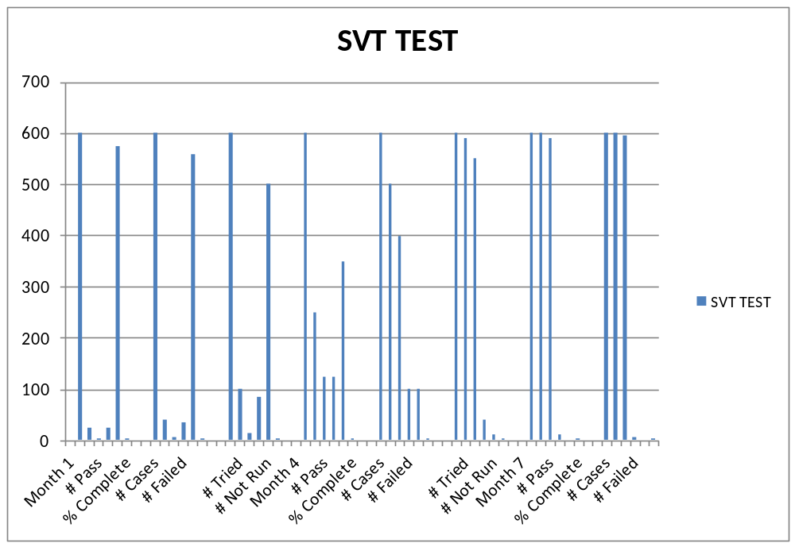

The first 4months we do not have integ .testing

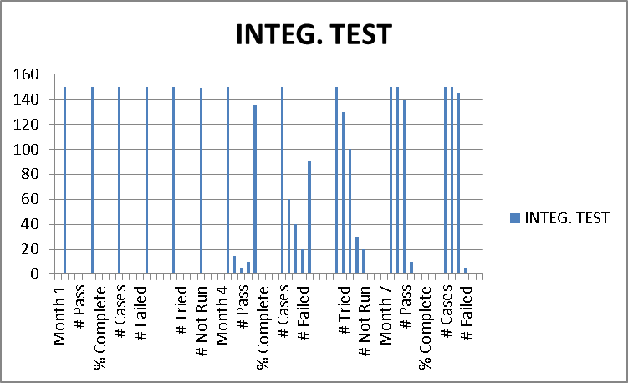

The last 3 months are so stress full

2.1 Security Considerations

There are a lot of open defects

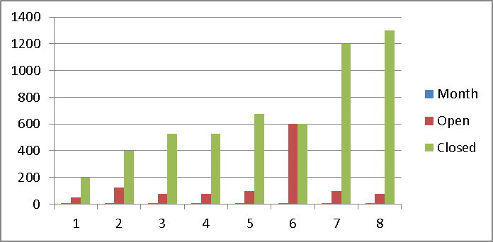

2.x [Test Identifier]

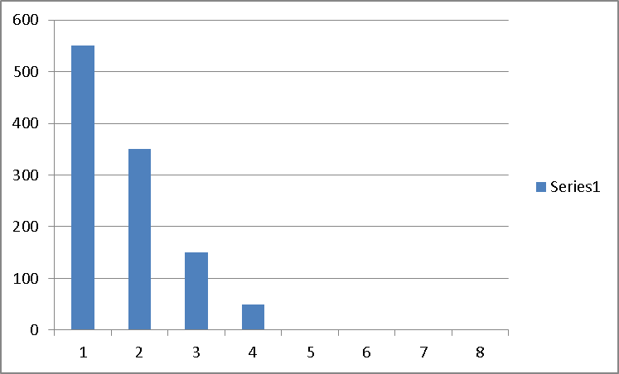
Not run unit test
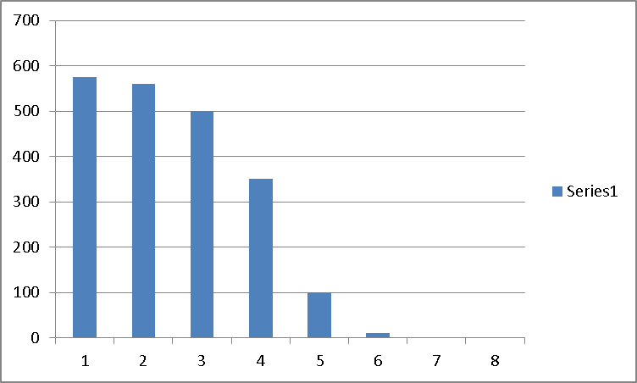
Not run SVT test
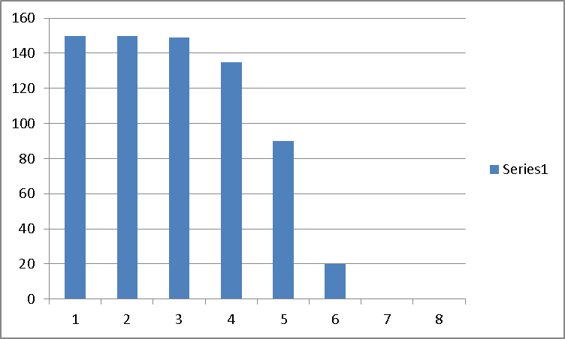
Not run intg. Test

Low performance

2.x.1 Expected Outcome

Software is expected to work normally.
Recommendations:
- Risk reduction
- Increased productivity.

2.x.2 Functional Capability

- Unequal execution of the tests
- High % Open bugs
- Load in the last 3 months

Cases by month –Try, Pass, Not run

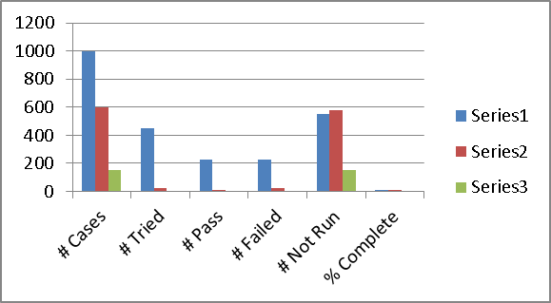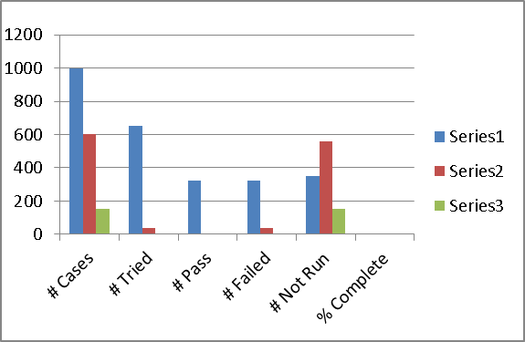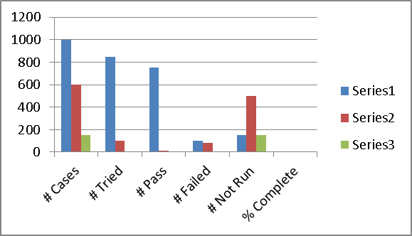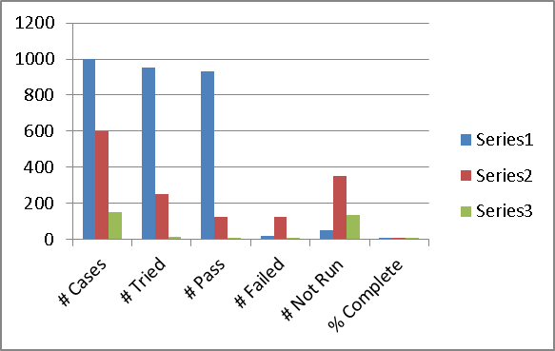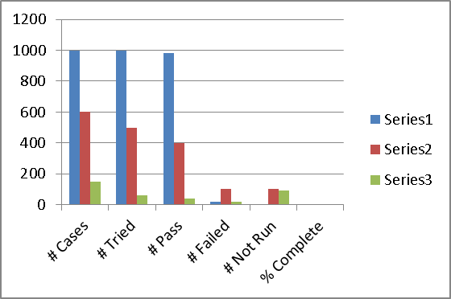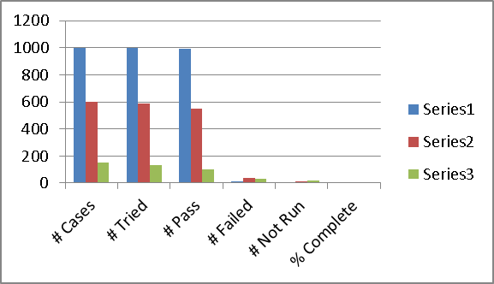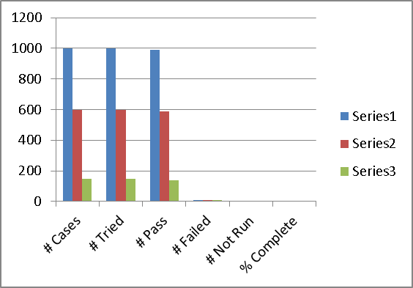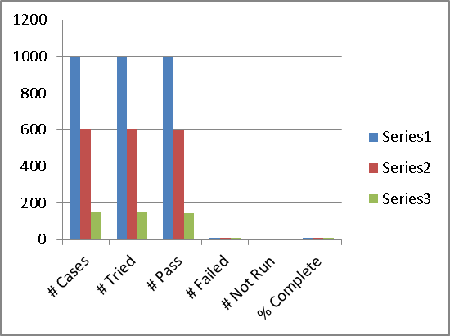

2.x.3 Performance

Month | Open | Closed
1 | 50 | 200 | 25
2 | 125 | 400 | 31.25
3 | 75 | 525 | 14.2857143
4 | 75 | 525 | 14.2857143
5 | 100 | 675 | 14.8148148
6 | 600 | 600 | 100
7 | 100 | 1200 | 8.33333333
8 | 75 | 1300 | 5.76923077

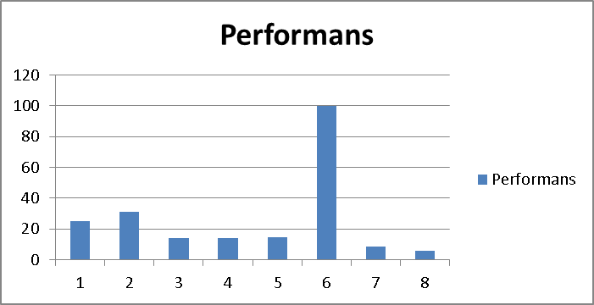

Low, critical performans

2.x.4 Deviations from Test Plan

The first four-months there is deviations from test plan

% try unit | % try SVT | %try integ.
45 | 4.166667 | 0
65 | 6.666667 | 0
85 | 16.66667 | 0.666667
95 | 41.66667 | 10
100 | 83.33333 | 40
100 | 98.33333 | 86.66667
100 | 100 | 100
100 | 100 | 100

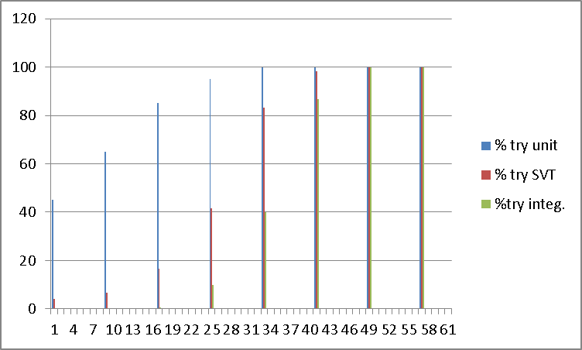

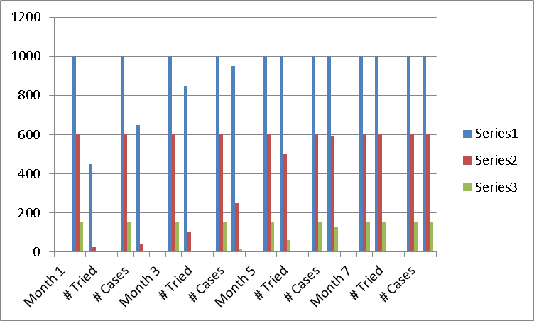

2.x.5 Risk
  - Project risk – related to how the project is managed
  - Product risk – risk associated with the actual product that is delivered to a customer
Product risk
- Key function omitted
- Unreliable (frequent fails)
- Cause financial damage
- Data integrity problems
- Data conversion problems
- Data backup problems
- Security problems
- Maintainability problems
- Performance problems
Analyses: Probability that the system or software might fail to satisfy some reasonable customer, user, or stakeholder expectation.
Risk-Action plan
- Starts early to identify system risks
- Mitigation - testing to provide the opportunity to reduce the likelihood of defects
- Contingency – testing to identify work around in the event of a failure
- Measuring – finding defects in critical areas
- Risk-analysis – proactively identify opportunities to remove defects
- Uses risk to prioritize and emphasize appropriate tests during test execution.

Product risk analysis
- Likelihood
- Impact
Project risks

- Some potential risks
  - Late code delivery
  - Availability of hardware
  - Excessive delays in bug fixes
- Potential options
  - Mitigate – take steps in advance to reduce the likelihood
  - Contingency – plan to reduce impact
  - Transfer – assign a team member to reduce likelihood
  - Ignore – do nothing – use only if likelihood and impact are low

3.0 SUMMARY AND CONCLUSIONS

summary and conclusions

3.1 Demonstrated Capability

3.2 System Deficiencies
- Unequal execution of the tests
- High % Open bugs
- Load in the last 3 months

3.3 Recommended Improvements

From test case execution status and bug closure rates recommended:

- Risk reduction
- Increased productivity.
- Recommended ship
Telerik TestStudio
Telerik TestStudio offers one solution to automate desktop, web, and mobile application testing including UI, load, and performance testing.

Telerik TestStudio offers various compatibilities like:

Support of programming languages like HTML, AJAX, ASP.NET, JavaScript, Silverlight, WPF, and MVC
Integration with Visual Basic Studio 2010 and 2012
Record and playback
Cross-browser testing
Manual testing
Integration with bug tracking tools

3.4 System Acceptance

